**S.4 SEMINAR QUESTIONS 2023**

1. **COMPULSORY QUESTION** – **MAP WORK.** **(20marks)**

Study the map extract 1:50000 (UGANDA) **BULISA**

Series Y732, sheet 29/4 and Edition 3-U.S.D and answer the questions that follow:

a) State the grid reference of

1. Road junction at Bulisa
2. Name the man made feature found at grid reference 271339.
3. Measure and state in Kilometres the distance of Wanseko to Butiaba & Masindi loose surface road.

b) Draw a sketch map of the area shown on the map extract and on it mark and name;

(i) Any two vegetation types,

1. Seasonal swamps,
2. Bulisa Town ship,
3. Loose surface roads.
4. A basin,
5. Contour lines 2050 and 2100.

c) Giving evidence from the map extract, describe the problems caused by the presence of Lake Albert. d) (i)Identify any **two** settlement patterns in the area shown on the map.

(ii) Describe the factors that have influenced settlement in the area shown on the map extract.

**2.COMPULSORY QUESTION: PHOTOGRAPH INTERPRETATION**

Study the photograph provided below and answer the questions that follow*.*

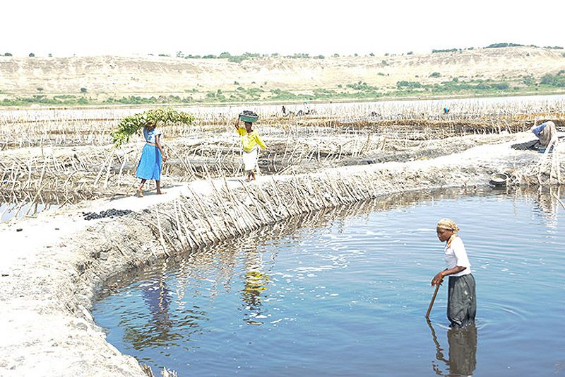

1. Giving evidence for your answer,
2. identify the type of photograph shown,
3. the economic activity taking place in the area shown in the photograph.
4. Describe the factors that have favoured the economic activity identified in (a) (ii) above.
5. Explain the contribution of the economic activity to economic development of any **one** country in East Africa.
6. Giving evidence for your answer, suggest one area in East Africa where this photograph could have been taken.

|  |  |
| --- | --- |
| **3. COMPULSORY QUESTION: FIELDWORK**  For any **one** fieldwork study you have conducted: | **(15 marks)** |
| (a) (i) State the topic of study, | (01 mark) |
| (ii) Outline the objectives of the study. | (03 marks |

1. Draw a relief – section of the area studied and on it, mark and name:
   * 1. physical features,
     2. land use activities.
2. Explain how the physical environment has influenced land use patterns in the area under study.
3. Outline the practical skills you obtained during the study.

**SECTION B: EAST AFRICA**

1. (a) Draw a sketch map of East Africa and on it, mark and name any **three** areas where glaciation is common.
   1. Explain the reasons why glaciation is limited to a few areas of East Africa.

(c) Mention any **two** features formed due to;

* + - 1. glacial erosion,
      2. glacial deposition.

(d) Outline the:

* + 1. economic importance of glaciation to East Africa.
    2. problems created by glaciation to East Africa.

1. (a) Differentiate between Gill netting and Lampara fishing methods.

(b) Mention any **two**:

(i) fresh water, (ii) marine fish species,

caught in East Africa.

(c) Explain the factors that have limited marine fishing in East Africa.

(d) What are the steps being taken to develop the fisheries sector in East Africa?

1. Study the sketch map of Tanzania provided below showing the major transport means and answer the questions that follow:

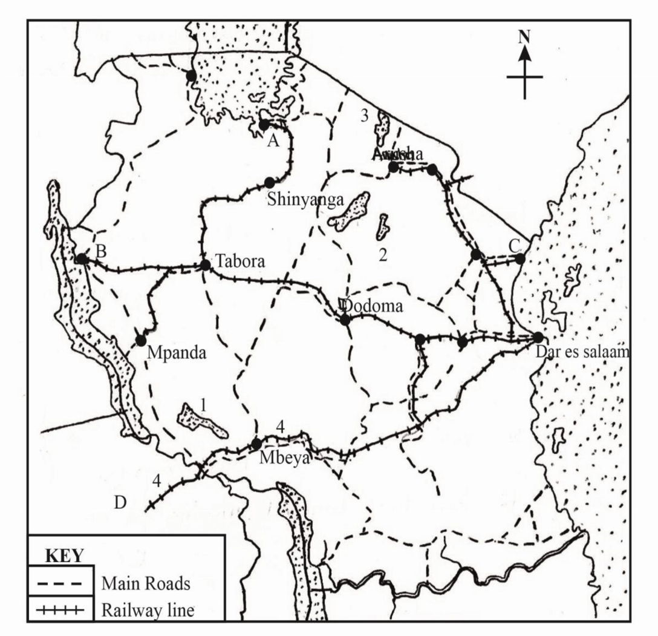

(a) Name the:

* + - * 1. ports marked **A**,**B** and **C**,
        2. country marked **D**,
        3. water bodies marked **1**, **2** and **3**,
        4. railway line marked **4**.
  1. Explain the contribution of **either** railway line marked **4** or port marked **C** to the development of Tanzania.
  2. Explain the factors which have influenced the distribution of transport routes shown on the map.
  3. Outline the problems facing the transport sector in East Africa.

1. Study the table below showing the number of tourist in East Africa (2004 – 2008) and answer the question that follow:

|  |  |
| --- | --- |
| **Year** | **Number of tourists** |
| 2004  2005  2006  2007  2008 | 350,981  380,321  439,846  456,388  475,201 |
| Total | 2,102,739 |

1. i) Draw a line graph to show the above information. ii) Describe the trend in the number of tourists as portrayed in the table and graph drawn in (a) i) above.
2. Explain the factors which have led to the trend in (a) (ii) above.
3. Outline the problems facing the tourist industry in East Africa.
4. Outline the measures being taken to improve the tourism industry in East Africa.

**GEOGRAPHY 273/2**

**THE REST OF AFRICA**

1. (a) Draw a sketch map of Africa and on it mark and name:
2. Highlands: Cape ranges, Adamawa and Ethiopian
3. Plateaus: Bie and Futa Djalon
4. Rivers: Zambezi and Niger.

(b) Describe the processes which were responsible for the formation of **either** Cape ranges **or** Ethiopian highlands.

(c) Explain the influence of highlands in Africa on rainfall distribution in the surrounding areas.

(d) Outline the importance of highlands to the people living in the surrounding areas.

1. Study the table below showing the climatic statistics for station X in Africa and answer the questions that follow:

|  |  |  |  |  |  |  |  |  |  |  |  |  |
| --- | --- | --- | --- | --- | --- | --- | --- | --- | --- | --- | --- | --- |
| Month | J | F | M | A | M | J | J | A | S | O | N | D |
| Temp0c | 22 | 23 | 22 | 21 | 19 | 17 | 17 | 18 | 21 | 22 | 23 | 23 |
| R/fall | 246 | 206 | 233 | 87 | 10 | 03 | 00 | 03 | 03 | 8 | 42 | 151 |

1. Draw a suitable graph to show the climate of station X.
2. Calculate the mean annual:

(i) temperature ,

(ii) rainfall, for the station.

1. Identify the type of climate represented in the table and graph above and give reasons to support your answer.
2. (i) Describe the human activities that can be carried out in the area around the station.

(ii)Outline the climate-related problems faced by the people in the area represented by station X.

1. Study the table below showing Cameroon’s volume of export crops (2013-2014) in metric tonnes and answer the questions that follow:

|  |  |  |
| --- | --- | --- |
| **Export crop** | **2013**  **(metric tonnes )** | **2014**  **(metric tonnes )** |
| Coffee | 13,000 | 60,000 |
| Oil palm | 1,700 | 30,000 |
| Tea | 79,000 | 290,000 |
| Sugar | 53,000 | 56,000 |
| Tobacco | 66,000 | 34,000 |
| **Total** | **212,700** | **470,000** |

1. Name the:

(i) least, (ii) most,

dominant export crop from Cameroon in 2013.

1. Draw a pie chart to show the relative importance of each export crop in 2013.
2. Explain the problems of depending on the exportation of agricultural products.
3. Outline the measures taken by Cameroon to address the problem of over depending on agricultural exports.
4. (a) Distinguish between **cattle ranching** and **nomadic pastoralism**.

(b)Name any:

(i) **two** countries where pastoralism is practiced.

(ii) **two** countries where cattle ranching is practiced.

(c) Describe the conditions which have led to the practice of **either** pastoralism **or** cattle ranching in any**one** country named in (b) above.

(d) (i)Outline the problems faced by traditional livestock farmers in any **one** country in Africa.

(ii) Using **specific examples**, explain the measures being taken to improve the livestock industry in Africa.

5. (a) Draw a sketch map of Egypt and on it mark and name the:

(i) Towns: Alexandria, Cairo and Idfu

(ii) Aswan high dam

(iii) Lake Nasser

(iv) Areas where petroleum, phosphates and manganese are obtained.

(b) Describe the conditions which have promoted industrialization in **either** Cairo **or** Alexandria.

(c) Explain the role of the industrial sector to the development of Egypt.

**(d)** Outline the environmental problems created by the industrial sector in Egypt.

1. Study table below showing the value of mineral sales in the Republic of South Africa (million Rand) in 2021 and answer the questions that follow:

|  |  |
| --- | --- |
| **Period** | **Value**  **(billion Rand)** |
| Jan-Feb | 119.72 |
| Mar-Apr | 155.35 |
| May-Jun | 156.77 |
| Jul-Aug | 149.33 |
| Sep-Oct | 130.17 |
| Nov-Dec | 138.26 |

1. Draw a line graph to represent the information in the table above.
2. Describe the method of extracting minerals that lie deep underground in the Rep. of South Africa.
3. Explain the importance of the mining sector in the development of Rep. of South Africa.
4. Outline the challenges facing the mining sector in Rep. of South Africa.

**STUDIES IN DEVELOPMENT**

**REGION I: NORTH AMERICA**

1. (a)Draw a sketch map of Canada and on it mark and name:

(i) the Canadian prairies

(ii) states: Alberta , Saskatchewan and Manitoba

(iii) **two** wheat export routes

(iv) **two** wheat export ports.

(b) Explain the physical conditions that have favoured extensive wheat growing in the Canadian Prairies.

(c) (i) State any **three** uses of wheat.

(ii) What are the challenges facing wheat exportation in Canada?

(d) Outline the measures being taken to control the problems in(c) (ii) above.

8. (a) Name any **two**:

(i) States in New England,

(ii) Traditional industries in New England,

(iii) New industries in New England.

(b) State the reasons for the decline of the old/ traditional industries in New England.

(c) Describe the factors that have favoured the development of the new industries in New England.

(d) Explain the challenges faced in the development of industries in New England.

1. (a)Draw a sketch map of Great lakes and St. Lawrence seaway , and on it mark and name the following:
2. Lakes: Superior, Huron and Ontario
3. Rivers: St. Lawrence and Ottawa
4. Canals: Sault Ste Marie and Welland
5. Gulf of St. Lawrence

(b) Explain why the St. Lawrence seaway was undertaken.

(c) What steps were taken in the construction of the seaway?

(d) State the benefits of the St. Lawrence Seaway to the people Canada and USA.

**REGION II: RHINELANDS**

1. (a) Draw a sketch map of the Rhine Rift Valley and on it mark and name:

(i) rivers: Rhine, and Main

(ii) Rhine Rift Valley and the Rhine gorge

(iii) towns: Manheim and Ludwigshafen

(iv) Vine growing areas.

(b) Describe the process which was responsible for the formation of the Rhine Rift Valley.

(c) Explain the conditions that have favoured vine growing in the Rhine Rift Valley.

(d) Outline the problems faced by the vine growers in the Rhine valley.

1. Study table below showing the value of dairy products in Belgium and answer the questions that follow:

|  |  |
| --- | --- |
| **Year** | **Value**  **(£ billion)** |
| **2016-17** | **2.45** |
| **2017-18** | **3.20** |
| **2018-19** | **3.18** |
| **2019-20** | **4.75** |
| **2020-21** | **4.97** |

1. Draw a line graph to show the information given in the table.
2. Describe the:

(i) trend in the value of dairy products between 2016 and 2022.

(ii) conditions which have caused the trend in (b) (i) in Belgium.

1. Explain the benefits of dairy farming to the people of Belgium.
2. Name any **two** dairy cattle breeds in Belgium.
3. (a) Draw a sketch map showing the Zuider Zee polders and on it mark and Name:

(i) North Sea

(ii) North Sea canal

(iii) River Yssel

(iv) North West polder, East polder and South polder

(b) Describe the process of land reclamation in the Netherlands.

(c) Explain the environmental problems which resulted from land reclamation in the Netherlands.

(d) Outline the measures that were taken to combat the problems in 8 (c) above.

**CHINA**

1. Study the table below showing the climate statistics of Hegang in Southern Heilongjiang and answer the questions that follow:

|  |  |  |  |  |  |  |  |  |  |  |  |  |
| --- | --- | --- | --- | --- | --- | --- | --- | --- | --- | --- | --- | --- |
| Month | J | F | M | A | M | J | J | A | S | O | N | D |
| Temp (0c) | -18 | -14 | -9 | -4 | 8 | 16 | 20 | 16 | 9 | -2 | -12 | -18 |
| R/fall  (mm) | 9 | 12 | 18 | 26 | 48 | 81 | 110 | 88 | 55 | 20 | 10 | 8 |

(a) Draw a suitable graph to show the climatic data in the table.

(b) Calculate the:

(i) Annual range of temperature

(ii) Total annual rainfall, for the station

(c) Describe the economic activities taking place in the area where the station is found.

(d) (i)Explain the environmental problems likely to be faced by the people living in the area around Hegang.

(ii) Suggest ways of improving the conditions of living in the area around Hegang.

1. Study the table below showing China’s imports by value in 2014 and answer the questions that follow:

|  |  |
| --- | --- |
| **Commodity** | **% of Total import value** |
| Food | 03 |
| Agricultural raw materials | 04 |
| Fuels | 12 |
| Ores and metals | 09 |
| Manufactures | 71 |
| Others | 01 |
| **Total import value in million US$** | **791,461** |

1. Draw a pie chart to show the importance of each import commodity.
2. Calculate the value spent by China on the importation of :

(i) ores and metals

(ii) food

1. Explain the ways through which import trade has developed the economy of China.
2. (i) Name any **one** port through which China imports agricultural raw materials and manufactured goods.

(ii)Outline the challenges facing China’s import trade.

15. (a) Draw a sketch map of china and on it mark and name:

(i) Towns: Beijing, Guangzhou and Tianjin

(ii) East China Sea

(iii)Rivers: Xi-Jiang, Chang Jiang and Huang He.

1. Describe the steps taken by china to develop the Yangtse Kiang River Basin.
2. Explain the value of the Yangtse Kiang River Basin to the people living in the surrounding areas.
3. Outline the problems that resulted from the development of the Yangtse Kiang River Basin.

**END**